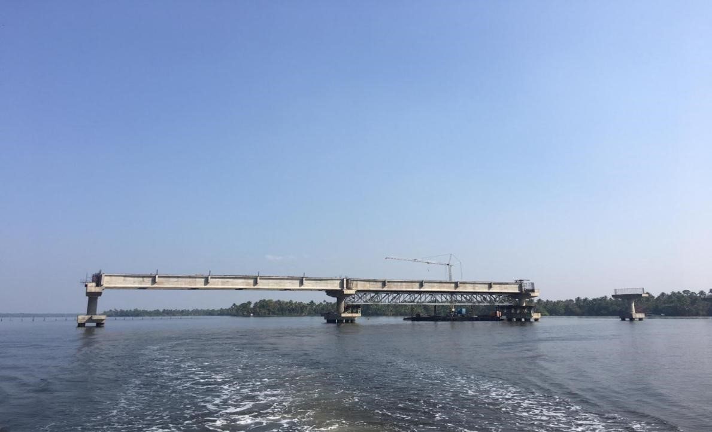
MAKKEKADAVU – NEREKADAVU BRIDGE

