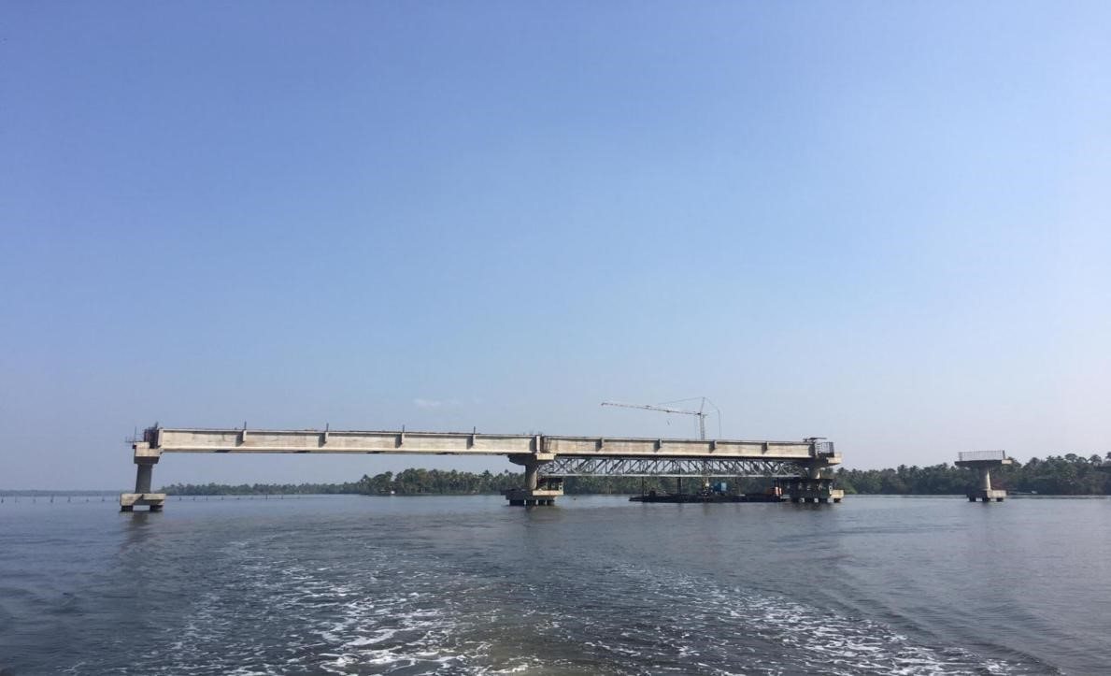
NEREKKADAVU-MAKKEKADAVU BRIDGE

