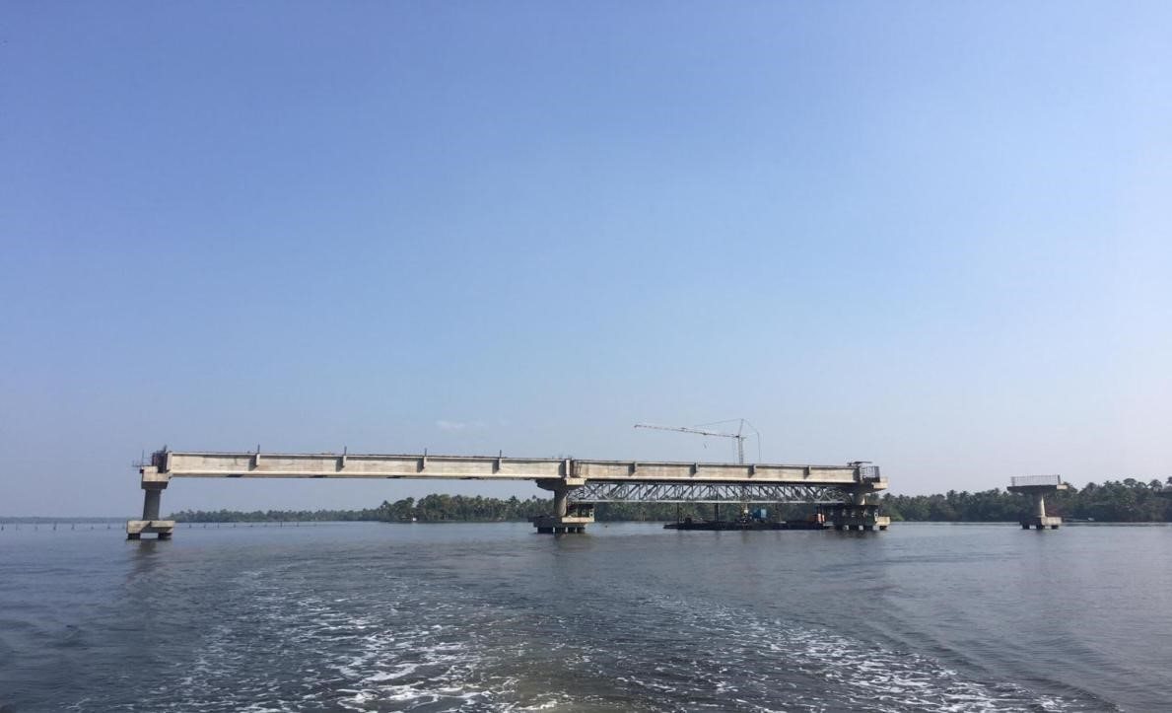

Construction of Nerekadav-Makkekadavbridge

